
Functional Specifications
This is the document that completely defines the specifications of a proposed system. This is the basic document, which will be used as the basis for implementation.
The paragraphs written in the “Comment” style are for the benefit of the person writing the document and should be removed before the document is finalized.
In order to gain technical and methodological background refer to the following books:
- Applying Use Cases by Geri Schneider, Jason P.Winters
- Applying UML and Patterns: An Introduction to Object Oriented Analysis and Design by Craig Larman
- Object Oriented Analysis and Design with Applications by Grady Booch
Version: <Fill version here>
<Date>

Prepared by:
Oleksandr Gudenko, Kihun Han, Tran Nham, Ifedayo Olaleye
Revision Chart
This chart contains a history of this document’s revisions. The entries below are provided solely for illustration purposes. Those entries should be deleted until the revision/s they refer to have actually been created.
The document itself should be stored in revision control, and a brief description of each version should be entered in the Revision Control System. A brief description can be repeated in this section. Revisions need not be described elsewhere in the document, unless they explain the document.

Version | Primary Author(s) | Description of Version | Date Completed
Draft | Oleksandr Gudenko | Initial draft created for distribution and review comments | 13.3.2018
Preliminary | Veijo Väisänen | Second draft incorporating initial review comments, distributed for final review | 12.2.2016
Final | Veijo Väisänen | First complete draft, which is placed under change control | 1.3.2016

Contents
New paragraphs formatted as Heading 1, Heading 2, and Heading 3 will be added to the table automatically. To update this table of contents in Microsoft Word, put the cursor anywhere in the table and press F9. If you want the table to be easy to maintain, do not change it manually.
1. Introduction 5
1.1 Project Overview 5
1.2 Problem Statement 5
1.3 Reference/ Source Documents 5
1.4 Goals 5
2. System Architecture 6
2.1 System Architecture Diagram 6
3. Use Case Model 7
3.1 List of Actors 7
3.2 List of Use Cases 7
3.3 Use Case Diagram 8
3.4 Use Case Buy Item 9
3.5 System Sequence Diagrams 10
3.6 User Interface 11
3.7 Data Dictionary 11
4. Glossary 12
5. Appendices 13

List of Figures
New figures that are given captions using the Caption paragraph style will be added to the table automatically. To update this table of contents in Microsoft Word, put the cursor anywhere in the table and press F9. If you want the table to be easy to maintain, do not change it manually.
This section can be deleted if the document contains no figures or if otherwise desired.
Figure 1 System Architecture 10
Figure 2 System Level Use Case Diagram 12
Figure 3 Conceptual Model 16

Introduction
This section should describe the project and the software product being to be built. No text is necessary between the heading above and the heading below unless otherwise desired.

Project Overview
The objective of this development project is a creation of online bank services with a supervisor. The idea is to make as realistic as possible banking solution including most of real online bank features such as:
- Log in system with encryption and additional security measure
(2-step authenticator)
- Personalized bank view
- Possibility of taking a loan, Move&Pay© money, Deposit&Withdraw© money
Give a short summary of the project objective and the system to be analyzed
Functional specifications are a description of needs or desires for a product. Identify and document what is really needed, in a form that clearly communicates to the client and to development team members. Define the requirements unambiguously, so that the risks are identified and there are no surprises when the product is finally delivered.
Following are the sample artifacts for this section:
- Problems or Overview Statement
- Customer
- Goals

Problem Statement
The purpose of this project is to …
The problem statement should be brief, comprising of no more than 50 words

Reference/ Source Documents
Provide references to all documents that have been consulted during the analysis phase.

Goals
This brief section should focus on what the client wants to achieve. It must enumerate the objectives of the top management and what it hopes to accomplish from the proposed system.

System Architecture
Describe the system architecture, or simply provide the architecture diagram. For School system it may include web based front end, webserver , database etc. Don’t worry too much about it just give a simple diagram of a typical web based project.

System Architecture Diagram
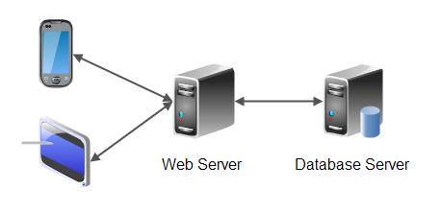
Figure 1 System Architecture

Use Case Model
Describe the following items:
- Actors & use cases
- Use case diagram
- High level, essential use cases
No text is necessary between the heading above and the heading below unless otherwise desired.

List of Actors
Define the system boundary and list all actors with the use cases.
For example:
Cashier; this person performs all the financial activities
Account Manager; this person supervises all financial activities

List of Use Cases
List all the use cases, with a brief description (should not exceed two lines):
Buy Item; captures a sale and its payment
Log In; allow user to provide account information and access the restricted services

Use Case Diagram
Create the system level use case diagram

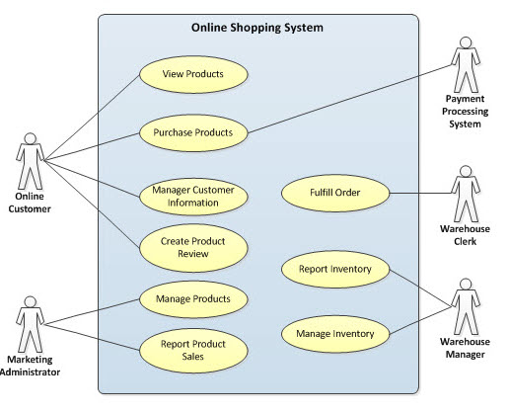

Figure 2 System Level Use Case Diagram

Use Case Buy Item
Document each use case. This can completed using the tables provided below:

Section: Main
Name: |  | Buy Item
Actors: |  | Customer, Cashier
Purpose: |  | Capture a sale and its payment.
Description: |  | A customer arrives at a checkout with items to purchase. The cashier records the purchase items and collects a payment. On completion, the customer leaves with the items.
Cross References: |  | Use Cases: Cashier must have completed the Log In use case. This is a reference to the System Functions as described in Section 1.10
Pre-Conditions |  | Assumption about the state of the system before execution of the operation
Successful Post-Conditions |  | State of the system after completion of the operation.
Failure Post-Conditions |  | State of the system after completion of the operation.
Typical Course of Events
Actor Action |  |  |  |  | System Response
1 | This use case begins when a customer arrives at the Point of Sale checkout with items to purchase.
2 | The cashier records each item |  |  |  | 3 | Determines the item price and adds the item information to the running sales transaction.
4 | … |  |  |  | 5 | …
7 | Customer selects payment type:  - If cash payment, see section Pay by Cash  - If credit payment, see section Pay by Credit
 |  |  |  |  | 8 | Logs the completed sale
 |  |  |  |  | 9 | Updates inventory levels
 |  |  |  |  | 10 | Generates a receipt
11 | Cashier gives the receipt to the customer
12 | The customer leaves with the items purchased
Alternative Course
Step 2: |  |  |  | Invalid item identifier entered. Indicate error.
Step 7: |  |  |  | Customer could not pay. Cancel sales transaction
Section: Pay by Cash
Typical Course of Events
Actor Action |  |  |  |  | System Response
1 | The customer makes a cash payment
2 | The cashier records the cash tendered |  |  |  | 3 | Presents the balance due back to the customer, if any.
4 | The Cashier deposits the cash received and extracts the balance owing and gives it to the customer
Alternative Courses
Step 1: |  |  | Customer does not have sufficient cash, may cancel sale or initiate another payment method.
Step 4: |  |  | Cash drawer does not contain sufficient cash to pay balance.

System Sequence Diagrams
This is an optional section. It may help when the Typical Course of Events (Section 3.4) is too detailed to clarify the flow properly.
A system sequence diagram is a picture that shows, for a particular scenario of a use case, the events that external actors generate, their order, and intersystem events. All systems are treated as a black box; the emphasis of the diagram is events that cross the system boundary from actor to systems.
A system sequence diagram should be completed for the typical course of events of the use case, and possibly others, for the most interesting alternative courses.

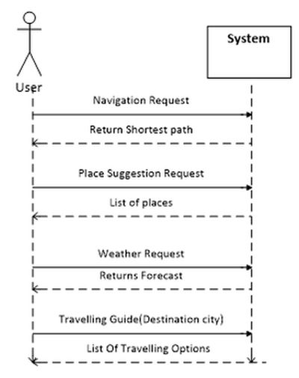

User Interface
This section may be used to provide screenshots of the application to give an idea of how the GUI will appear.

Data Dictionary
This section may be used to provide the details of interface elements that are present on the screenshots.

Element Name | Type | Validation | Mandatory | Remarks

Glossary
A glossary or model dictionary lists and defines all the terms that require clarification in order to improve communication and reduce the risk of misunderstanding.
Record domain or business terms, rules, concepts, etc. in the glossary

 | Comments
DS | DS stands for Directing Staff, a class instructor
Div | Stands for a Division with fixed strength and organization
Package | ….

Appendices
Include supporting detail that would be too distracting to include in the main body of the document.

